**DATA SIZES**

**BITS**

* A bit is a binary digit, the smallest increment of data on a computer. A bit can hold only one of two values: 0 or 1, corresponding to the electrical values of off or on, respectively.

## **BYTES**

* A Byte is a small storage unit that contains 8 bits. Here is what a Byte looks like:

01101110

* A Byte can be used to store an integer between 0 and 255, or a single character (using the ASCII code).

**KILOBYTE**

* A kilobyte (KB) contains 1024 Bytes.
* 1 KB = 1024 Bytes
* A text file is often measured in Kilobytes as it would contain a few thousand characters.

**MEGABYTE**

* A megabyte (MB) contains 1024 kilobytes.
* 1 MB = 1024 KB.

= 1024 x 1024 Bytes.

* A digital photograph or an mp3 would typically take up a few megabytes of disk space.

**GIGABYTE**

* A gigabyte (GB) contains 1024 megabytes.
* 1 GB = 1024 MB.

= 1024 x 1024 KB.

= 1024 x 1024 x 1024 Bytes.

* A high quality movie (DVD) would take up a few gigabytes. An SD card or USB key would contain a few GB of data.

**TERABYTE**

* A terabyte (TB) contains 1024 gigabytes.
* 1 TB = 1024 GB.

= 1024 x 1024 MB.

= 1024 x 1024 x 1024 KB.

= 1024 x 1024 x 1024 x 1024 Bytes.

* A hard drive can contain a few Terabytes of data.

**PETABYTE**

* A petabyte (PB) contains 1024 terabytes.
* 1 PB = 1024 TB.

= 1024 x 1024 GB.

= 1024 x 1024 x 1024 MB.

= 1024 x 1024 x 1024 x 1024 KB.

= 1024 x 1024 x 1024 x 1024 x 1024 Bytes.

* Very large databases stored on web servers used by large websites (Google, Facebook, etc…) will contain a few Petabytes of data.

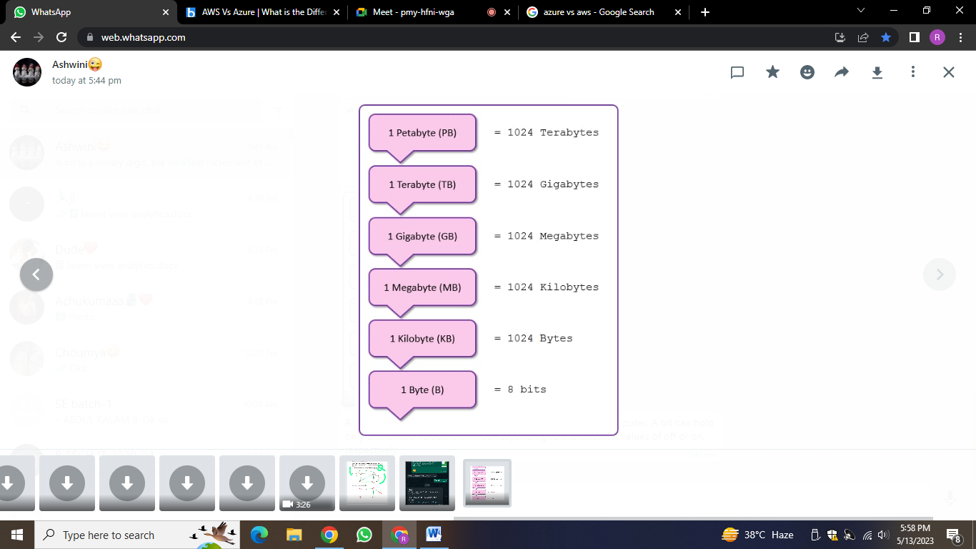

**ADVANTAGES AND DISADVANTAGES**

